***Tracking Evaluation***

The Multiple Object Tracking (MOT) metrics "multiple objects tracking precision" (*MOTP*) and "multiple object tracking accuracy" (*MOTA*)

**Metrics**

1. **MOTA**

The *MOTA* accounts for all object configuration errors made by the tracker, false positives, misses, mismatches, overall frames.

**MOTA = 1 - $\frac{\sum{}( misses, false positive, mismatches )}{total number of ground truth }$**

1. **MOTP**

It is the ratio between the number of Positive samples correctly classified to the total number of samples classified as Positive (either correctly or incorrectly).

It shows the ability of the tracker to estimate precise object positions, independent of its skill at recognizing object configurations, keeping consistent trajectories, and so forth.

**MOTP = $\frac{ \sum{}sum of overlap between predicted and actual bounding box}{total number of positive predicted bounding boxes }$** 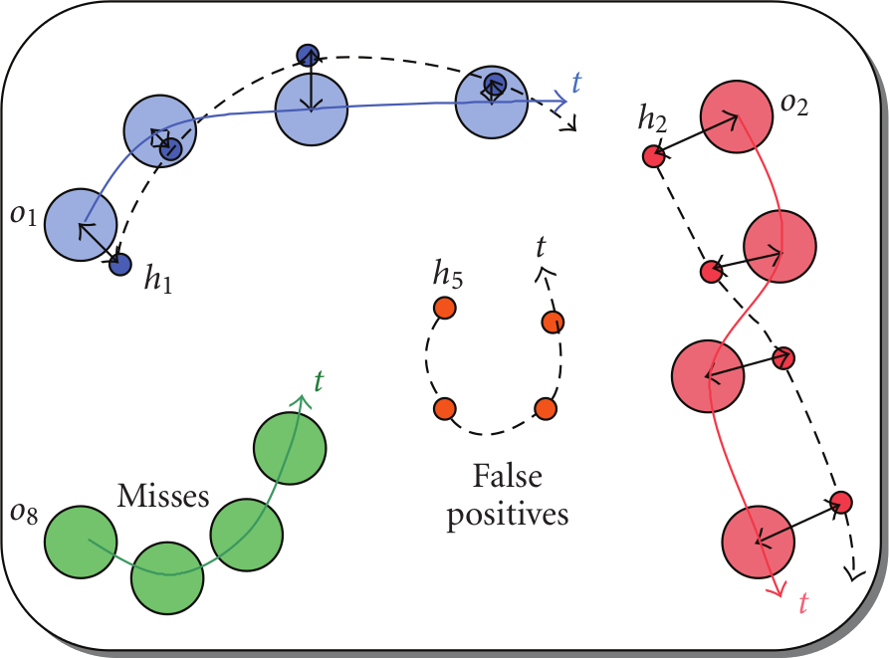

Procedure for the systematic and objective evaluation of a tracker’s characteristics. Assuming that for every time frame t, a multiple object tracker outputs a set of hypotheses {h1, . . . , hm } for a set of visible objects {o1, . . . , on }, the evaluation procedure comprises the following steps.

For each time frame t,

1. establish the best possible correspondence between

hypotheses hj and objects oi

1. For each found correspondence, compute the error in the object’s position estimation,

3. accumulate all correspondence errors:

1. Count all objects for which no hypothesis was output as **misses**.
2. Count all tracker hypotheses for which no real object exists as **false positives.**
3. Count all occurrences where the tracking hypothesis for an object changed compared to previous frames as **mismatch errors**.

**Procedure**

Let M0 = {·}. For every time frame t, consider the following.

1. For every mapping (oi, hj) in Mt−1. If object oi is still visible and tracker hypothesis j still exists at time t, and if there IoU ( Intersection over Union ) exceeds the threshold. make the correspondence between oi and hj for frame t.
2. For all objects for which no correspondence was made yet, try to find a matching hypothesis. Allowing only one-to-one matches, and pairs for which the IoU between predicted and ground truth exceed the threshold.

The matching assignment is done through **Munkres Algorithm**. If a correspondence (oi, hk) is made that contradicts a mapping (oi, hk ) in

Mt−1, replace (oi, hj ) with (oi, hk ) in Mt. Count this as **mismatch error**

1. After the first two steps, a complete set of matching pairs for the current time frame is known. Let ct be the number of matches found for time t. For each of these matches, calculate the IoU between the object oi and its corresponding hypothesis.
2. All remaining hypotheses are considered **false positives**. Similarly, all remaining objects (ground truth) are considered **misses**.
3. Repeat the procedure from step 1 for the next frame. Note that since for the initial frame, the set of mappings M0 is empty, all correspondences made are initial and no mismatch errors occur.

**Results**

Results for IoU threshold: 0.5:

MOTA: 0.7994335736354274

MOTP: 0.7660714207010106

Ground truths 3884

False positives 757

Misses 10

Mismatches 12

Correspondences 3874

**References**

1. Code Repo ([Github](https://github.com/Videmo/pymot))
2. Research Paper ([Link](https://jivp-eurasipjournals.springeropen.com/track/pdf/10.1155/2008/246309.pdf))